News Release
Everett Public Schools

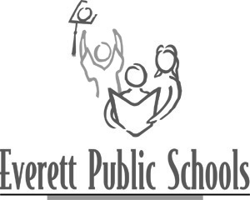

April 29, 2009
For more information:
Mary Waggoner, 425-385-4049
Peter Scott, Gateway Middle School principal, 425-385-6600

Gateway Middle School seventh-grader wins state essay contest
Kaitlin Costello is the Grand Prize winner of the PTA Men Essay Contest, sponsored by Washington State PTA. On Saturday, May 2, Kaitlin will be reading her essay Dad at the Washington State PTA Convention where she will also be presented with her award. Kaitlin’s essay will also be published on the WSPTA Web site and in a future issue of Child Advocate magazine.

All entries submitted were judged and narrowed to 78 (eight essays from each of the 13 WSPTA regions). From the 78 regional winning essays, four finalists were then selected as statewide winners. Finally, a panel selected one winning essay from each of the four age groups. Kaitlin’s essay was selected as the Grand Prize winner for grade 6-8.

Gateway PTSA 2008-09 and 2009-10 board members will attend the Washington State PTA Convention and the awards ceremony on Saturday to congratulate Kaitlin and her parents, Peggy and Michael Costello.

